**Assignment 1 - Expand the VLAN based network**

**Cathal Lawlor - 21325456**

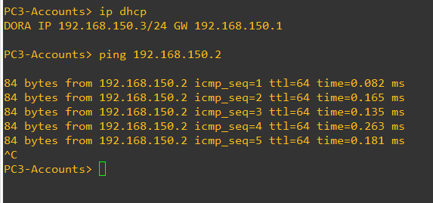**5. Able to ping one another on the VLAN**

Here we see two other VPC’s with dhcp IPs of 192.168.150.3 & 192.168.150.4 pinging 192.168.150.2, all on the same VLAN. (It works)

**6. Pinging to another VPC in the same VLAN (VLAN 150)**

This is 192.168.150.3 with running a trace to 192.168.150.2, another VPC on the same VLAN. The switch directs it immediately to the .2 VPC as it is on the same VLAN.

**7. Pinging to another VPC in a different VLAN (VLAN 100 -> 150)**

This is 192.168.100.2 with running a trace to 192.168.150.2, a VPC on the 150 VLAN, not its own 100 VLAN. The switch directs it to the VLAN 100 gateway at 100.1, where it is routed from there to 150.2.

**8. Packet capture Pinging different VLAN**

The 802.1q protocol here, also referred to as Dot1q, is the networking standard that supports VLANs (virtual local area networking) on Ethernet. It adds a VLAN tag to the ethernet frame carrying the ARP request. This helps routers and switches identify the VLAN to which the frame belongs. It is crucial to ensure correct routing between VLANs, for isolating and distinguishing traffic between VLANs.

The first of the 2 ARP packets are the VPC’s looking for the router gateway of its VLAN. The second is the response, letting the VPC know the MAC address for the gateway. (ARP packets being used for VLAN Gateway discovery, where 802.1q tagging is added)

Following that, (with some failed pings due to timeout), the VPC on VLAN-100 pings the second VPC on VLAN-150, requesting that it to reply to it.

The 2 ARP following the ping request packets are the VLAN-150 VPC looking for its own VLAN’s gateway. The VPC is then sent the MAC address.

Following that, we are capturing the ping replies by 192.168.100.2 VPC, and the requests being sent by the 192.168.150.2 VPC again. These are all tagged with 802.1q tags to keep packets separate by VLAN, ensuring correct destination.

Bonus part – Discussed in lab with Des  
The router sends out ARP requests to the two VPCs, from their respecting VLAN gateways. This is most likely the router **being ‘aggressive when it comes to populating its tables and, upon hearing ARP traffic or being involved in ARP messages, will subsequently generate their own ARP requests to populate their tables.**’

My theory is based off this [here](https://superuser.com/questions/1360760/why-does-the-2nd-arp-request-wait-until-the-pings-are-over-to-show-up), it is not connected to the pinging between the two VPC’s as it is 5 seconds later, which would indicate it is independent to our objective focus.